**HR Attrition Dashboard Report**

**1. Executive Summary**

Employee attrition remains one of the most critical challenges for organizations. The **HR Attrition Dashboard**, developed using Power BI and Excel, provides actionable insights into employee turnover by analyzing key metrics such as demographics, turnover trends, job roles, and employee satisfaction. This report summarizes the insights derived from the dashboard and proposes strategies to improve employee retention and engagement.

**2. Introduction**

The HR Attrition Dashboard leverages workforce data to uncover trends and inform decision-making. By integrating data visualization and statistical analysis, the dashboard empowers HR teams to:

* Monitor attrition trends across departments, roles, and demographics.
* Identify root causes of employee turnover.
* Develop targeted strategies to improve retention rates.

**3. Tools and Methodology**

**Tools Used:**

* **Power BI**: To design and develop interactive, user-friendly dashboards.
* **Excel**: For data cleaning, manipulation, and preliminary analysis.

**Dataset Overview:** The dataset includes **1,470 employee records** and **38 attributes**, categorized into:

* **Attrition Indicators**: Departure status of employees.
* **Demographics**: Age, gender, marital status, education, and job role.
* **Work Metrics**: Monthly income, years at company, travel frequency.
* **Satisfaction Metrics**: Job satisfaction, work-life balance, and performance ratings.

**4. Dashboard Overview**

The HR Attrition Dashboard consists of five key sections:

**4.1 Landing Page**

* Provides a high-level overview of the dashboard.
* Serves as a navigation hub to explore detailed insights on demographics, turnover, and wellness.

**4.2 Demographics**

* **Description**: Summarizes workforce demographics, including age groups, gender distribution, marital status, and commuting patterns.
* **Insights**:
  + Employees aged 18–30 and 31–45 account for the highest proportion of attrition.
  + Gender distribution and marital status offer additional context for attrition analysis.
* **Usage**: Helps understand workforce diversity and commuting challenges.

**4.3 Turnover Analysis I**

* **Description**: Focuses on turnover across departments, job roles, business travel frequency, and years in the current role.
* **Insights**:
  + Specific departments and roles exhibit higher attrition rates.
  + Frequent business travel correlates with higher attrition.
* **Usage**: Supports targeted retention strategies for vulnerable groups.

**4.4 Turnover Analysis II**

* **Description**: Examines turnover based on job level, overtime, performance ratings, monthly income, and trends.
* **Insights**:
  + High overtime employees and those with lower performance ratings are more likely to leave.
  + Monthly income is an influencing factor in attrition.
* **Usage**: Helps HR teams design policies for workload management and salary adjustments.

**4.5 Employee Wellness**

* **Description**: Analyzes factors like job satisfaction, environment satisfaction, job involvement, relationship satisfaction, and work-life balance.
* **Insights**:
  + Employees with low satisfaction ratings are more prone to attrition.
  + Work-life balance significantly influences retention.
* **Usage**: Informs wellness programs and employee engagement initiatives.

**5. Key Insights and Trends**

1. **Age Group Trends**:
   * Employees aged 18–30 and 31–45 show the highest attrition rates.
   * Career advancement opportunities and work-life balance are critical for these groups.
2. **Job Role Analysis**:
   * Laboratory Technicians experience higher attrition rates, indicating possible dissatisfaction or limited career growth.
3. **Satisfaction Metrics**:
   * Low environment and job satisfaction correlate strongly with high attrition rates.
4. **Work-Life Balance**:
   * Poor work-life balance is a major factor contributing to turnover.

**6. Strategies to Reduce Attrition**

1. **Age Group Interventions**:
   * Offer flexible work options and clear career advancement paths for employees aged 25–34.
2. **Role-Specific Strategies**:
   * Design career development programs tailored to roles like Laboratory Technicians.
   * Provide frequent feedback and recognition.
3. **Employee Wellness**:
   * Invest in wellness programs focusing on environment satisfaction, work-life balance, and relationship satisfaction.
4. **Onboarding and Mentorship**:
   * Implement comprehensive onboarding processes for new hires.
   * Assign mentors to guide and support employees in their initial years.

**7. Conclusion**

The HR Attrition Dashboard provides actionable insights into workforce trends, enabling organizations to move from reactive to proactive HR management. By focusing on the identified areas—age groups, job roles, and satisfaction metrics—companies can significantly reduce attrition rates and improve employee engagement.

**Next Steps:**

1. Prioritize retention strategies for high-risk groups (e.g., Laboratory Technicians, employees aged 18–30).
2. Roll out wellness programs to improve job satisfaction and work-life balance.
3. Regularly update and monitor the dashboard to track progress and refine strategies over time.

**8. Appendix**

**Screenshots of the Dashboard:**

1. **Landing Page**

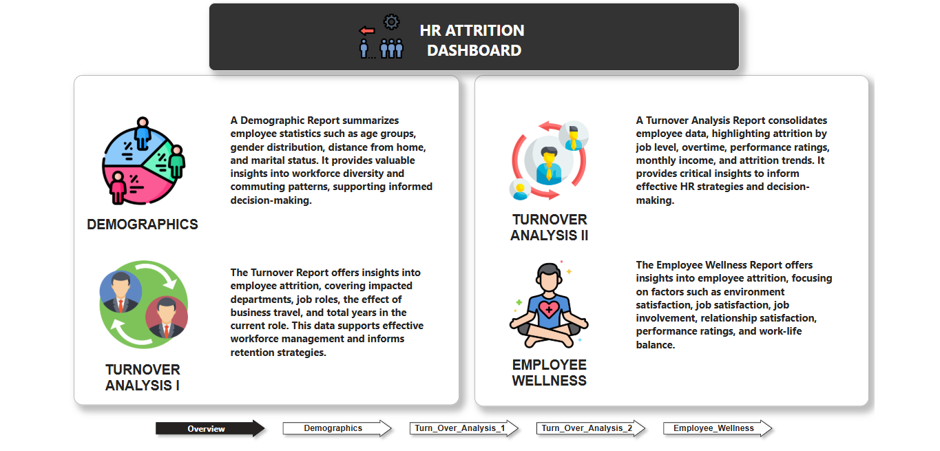

1. **Demographics Report**

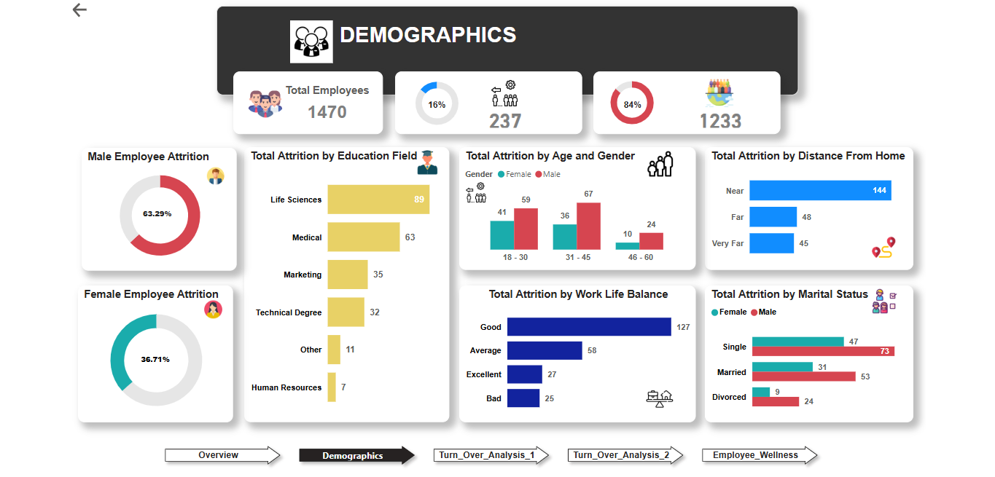

1. **Turnover Analysis I**

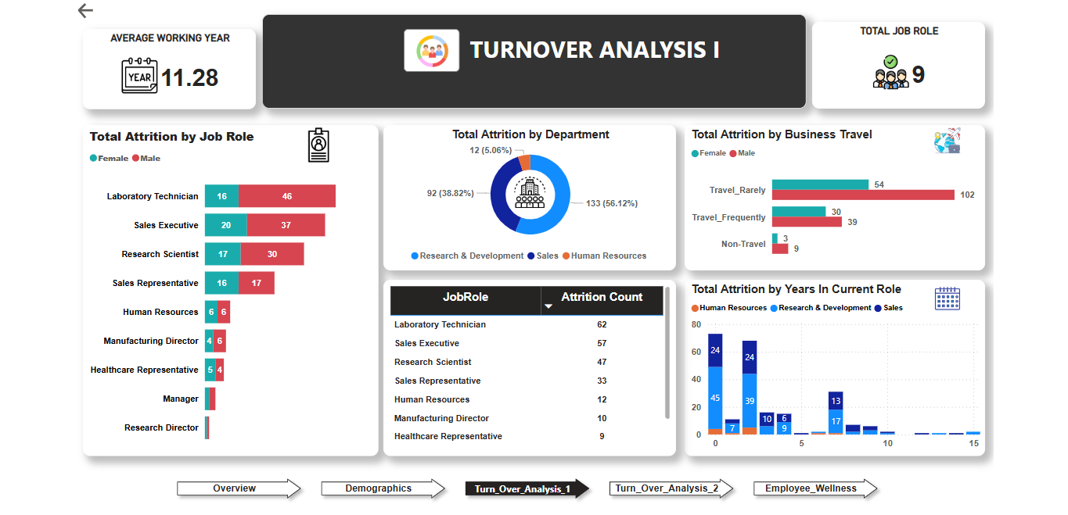

1. **Turnover Analysis II**

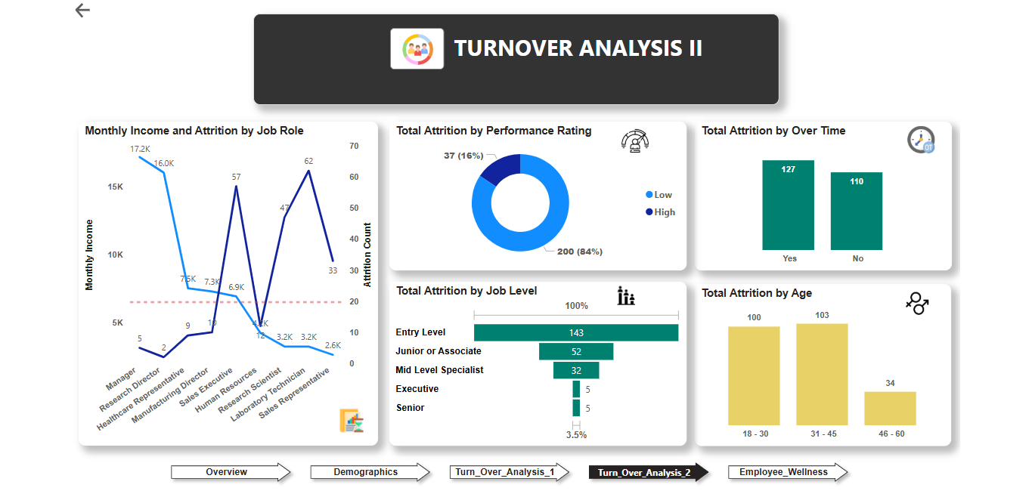

1. **Employee Wellness Report**

